Technical Proposal (TP)
Date: 29 December 2011
1. Management plan
Shenzhen Puxin Technology Co. Ltd. is a private enterprise founded in 2001. Since its establishment, the company has been concentrated in the development of Puxin biogas system and the products needed to build the system. After successfully completing the development of Puxin family size biogas system, the company began to develop of Puxin medium and large size biogas system in 2003.
In 2006, Puxin Biogas system won the “Blue Sky Award” granted by United Nations Industrial Development Organization and Shenzhen International Technology Promotion Center for Sustainable Development.
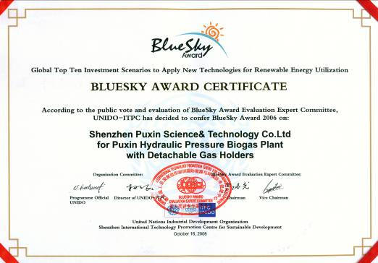
Please pay attention that our company had changed our company name to Shenzhen Puxin Technology Co. Ltd this October.
By the end of Sep. 2011, Puxin products for biogas development have been exported to nearly fifty countries as well as the international organizations UNDP, WFP and SNV. In China Puxin biogas system has been extended to over ten provinces.

Shenzhen Puxin Technology Co. Ltd will become responsible for the contract. Please pay attention with our company’s business model with regard to our family size and medium size biogas system that we design the biogas system, sell the equipments needed to build the system to our customers, train the technicians for them and our customers build the biogas system themselves.

2. Experience in family size biogas plants

1. In Timor Leste
Each year, Timor-Leste purchases our family size biogas equipments annually to build Puxin family size biogas plants for their country. The businesses are under the support of UNDP.

Contact:
Government of Democratic Republic of Timor-Leste
Dili Timor Leste
Contact: Mr. Aries Eddie de Almeida
Tel: +670-7242748
E-mail: dalmukelect@gmail.com

Puxin family size biogas system built in Timor Leste

A 10m3 Puxin family size biogas plant with two extra gasholders built in Timor Leste can provide enough biogas for three families for their daily cooking and water boiling.
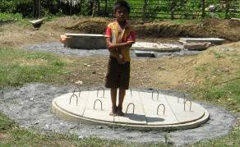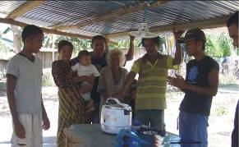

2. In the middle of 2011, the WFP ordered 400 sets of Puxin family size biogas equipments which are built in Sudan. Now the biogas plants are under construction.

Contact:
Mr. Amit Kumar Singh
Programme Officer
United Nations World Food Programme
North Darfur Area Office,
North Darfur,Sudan
Mobile- 00249 912317841
Amit.Singh@wfp.org

Hamed Adlan
Procurement Unit
WFP Khartoum
Sudan
Email: Hamed.Adlan@wfp.org
+249912153007

3. In Ghana

Contact
Mr. Kofi Ahenkorah
BETA CONSTRUCTION ENGINEERS LIMITED
P. O. BOX K.I.A. 9329 ACCRA- GHANA
TEL: 233-21-404186, 233-24-6865689/4239539
FAX: 233-21-404186
E-MAIL: betaconst@yahoo.com

Puxin biogas plants built in Ghana
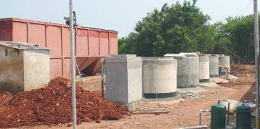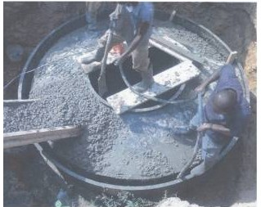

4. In Kenya

Contact
Ms. Martha Pleijel
Kenya Puxin Renewable Energy Co.,Ltd
Address : Cigma business centre, Office 208 in Nyahururu
Tel: 00 254 725 858 775, 0720957881
Email: marthapleijel@yahoo.se
kenyapuxin07@yahoo.com .

Puxin biogas plants built in Kenya
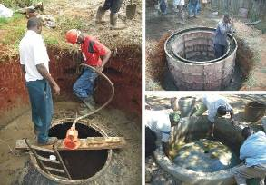
5. Puxin biogas plants built in South Africa
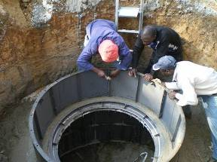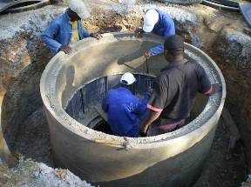
6. Puxin biogas plants built in Chile 7. Puxin biogas plants built in France
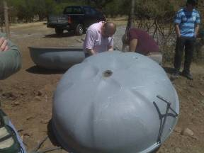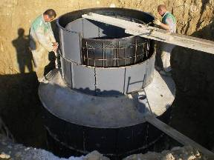

8. Puxin biogas plants built in Spain 9. Puxin biogas plants built in Israel
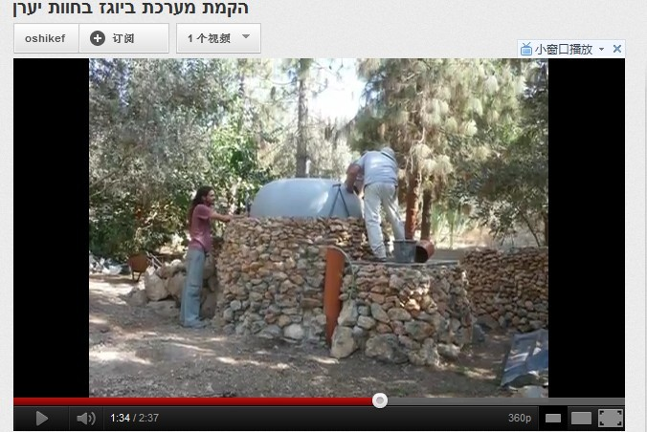
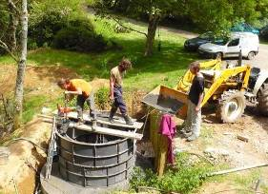

Dr. Jianan Wang will represent the Offeror- Shenzhen Puxin Technology Co. Ltd in any future dealing with the procuring UNDP entity.
Shenzhen Puxin Technology Co. Ltd
Location: 1-2nd floor, Bldg 4, Masha Xuda High-tech. Industry Park, 49 Jiaoyu North Dd, Gaoqiao, Pingdi , Longgang, Shenzhen, P. R. China
Postal code: 518117
TEL: +86-755-28938251, 28938252
FAX: +86-755-89323983
E-mail: info@puxintech.com
Website: http://www.puxinbiogas.com

3. Resource plan

(1) The Puxin 10m3 family size biogas system is suitable to treat the animal waste
100kg and 150kg fresh fermentation substrate
Primarily cow/buffalo dung, mixed with waste from donkey, chicken litter, etc
per day.

Puxin10m3 family size biogas plant

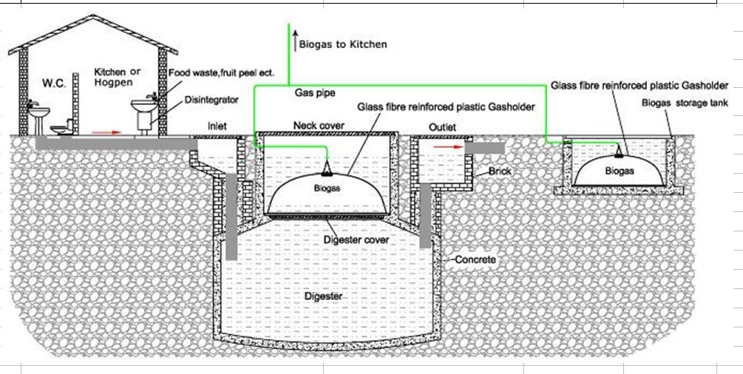
The digester is 2.9m deep, 2.8m in diameter and 10m3 of capacity. The gas-holder is 1.6 m in diameter, 0.6 m high and 1 m3 of capacity
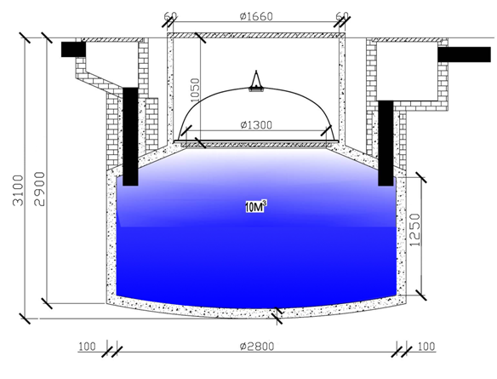

Total cost (CIF SOKHNA EGYPT) for the equipments needed to build 50 sets of Puxin family size 10m3 biogas plants as attached.

PUXIN family size biogas system
The family size biogas system is composed of one or several 10m3 biogas plants formed into a unit, the pipe system, the gas purify devices and the appliances. The family size biogas system is mainly applied to family house to treat sewage and food waste.

Our products include: the steel mould that is equipment used to build the concrete digester of the 6 or 10m3 Puxin biogas plant, the glass fiber gasholder that is a components of the 6 or 10m3 Puxin storage biogas plant, the biogas transport system, the biogas appliances (stove, water heater, rice cooker, lamp etc.), and small power biogas generators

The steel mould is composed of a number of steel mounding boards. By using a steel mould a 6 or 10 m3 puxin biogas digester can be build in two days, or 150 in a year. The steel mould is reusable and can be used over 2000 times, last over ten years.

The glass fiber reinforced plastic gasholder is 1.0 m3 that is one of the main components of the puxin biogas plant, and it can last over 10 years.

For family size biogas system we sell all the equipments and products needed to build the biogas system to our customers, train the technicians for them, and our customers build the biogas application system themselves.

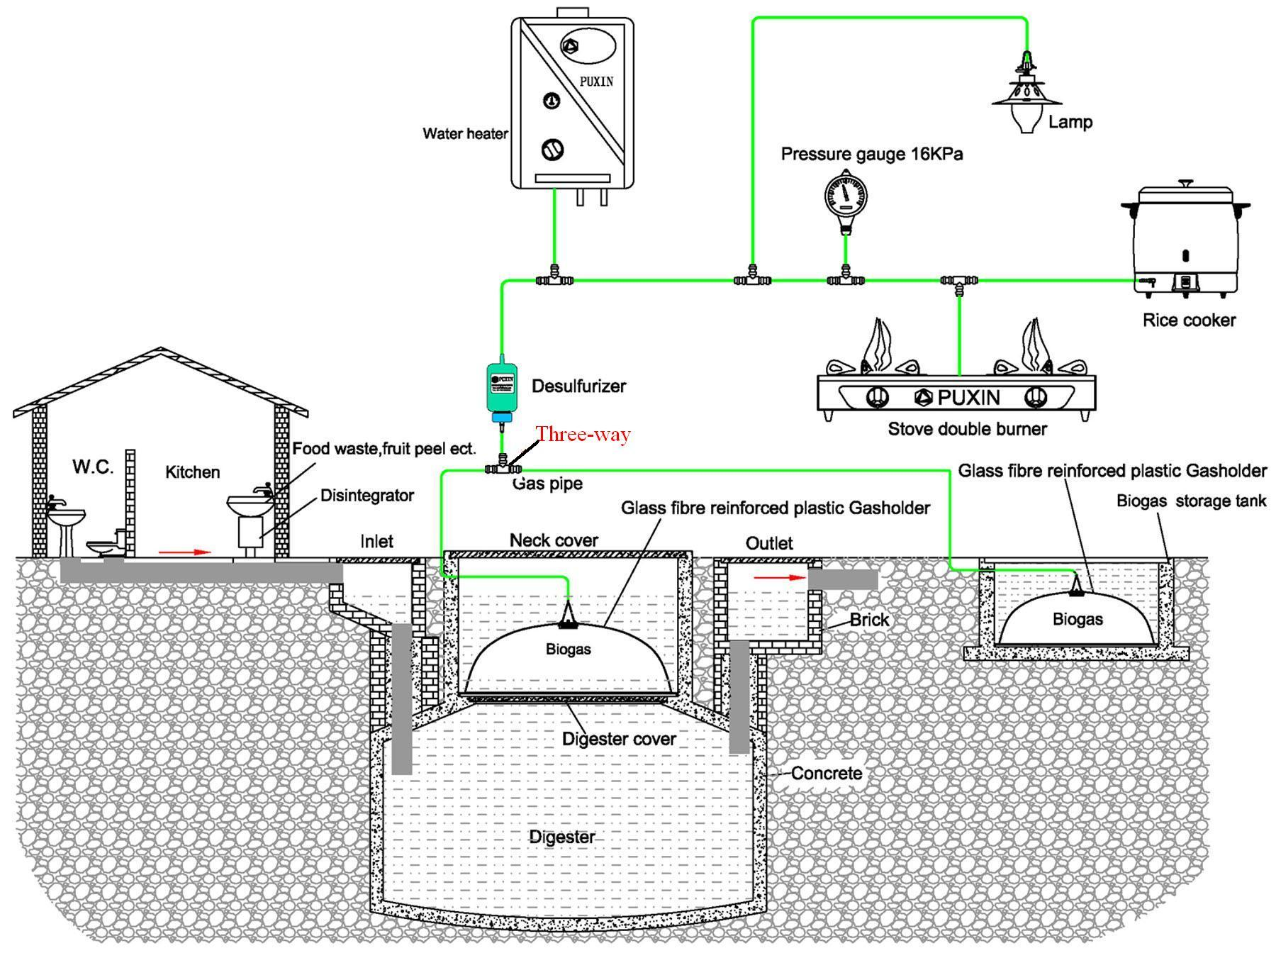

With 10 m3 family size Puxin biogas plant as per the above drawing, enough biogas can be provided to 2 families of 4 persons each for cooking and lighting.
The digester is made of concrete.

By making use of steel mould with outer 10 m3 to construct, which is can be reusable for many times:
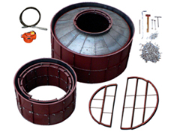

The construction material needed to install the 10 m3 digester:

Material | Q’TY
Smashed stone | 4.0 M3
Sand | 3.5 M3
Cement | 1400 Kgs
Brick | 100 Pcs
Plastic pipe | 4 Meter
Concrete bar | 8 Kgs

Storage system:
Main component
- concrete tank
- glass fiber reinforced plastic gasholder

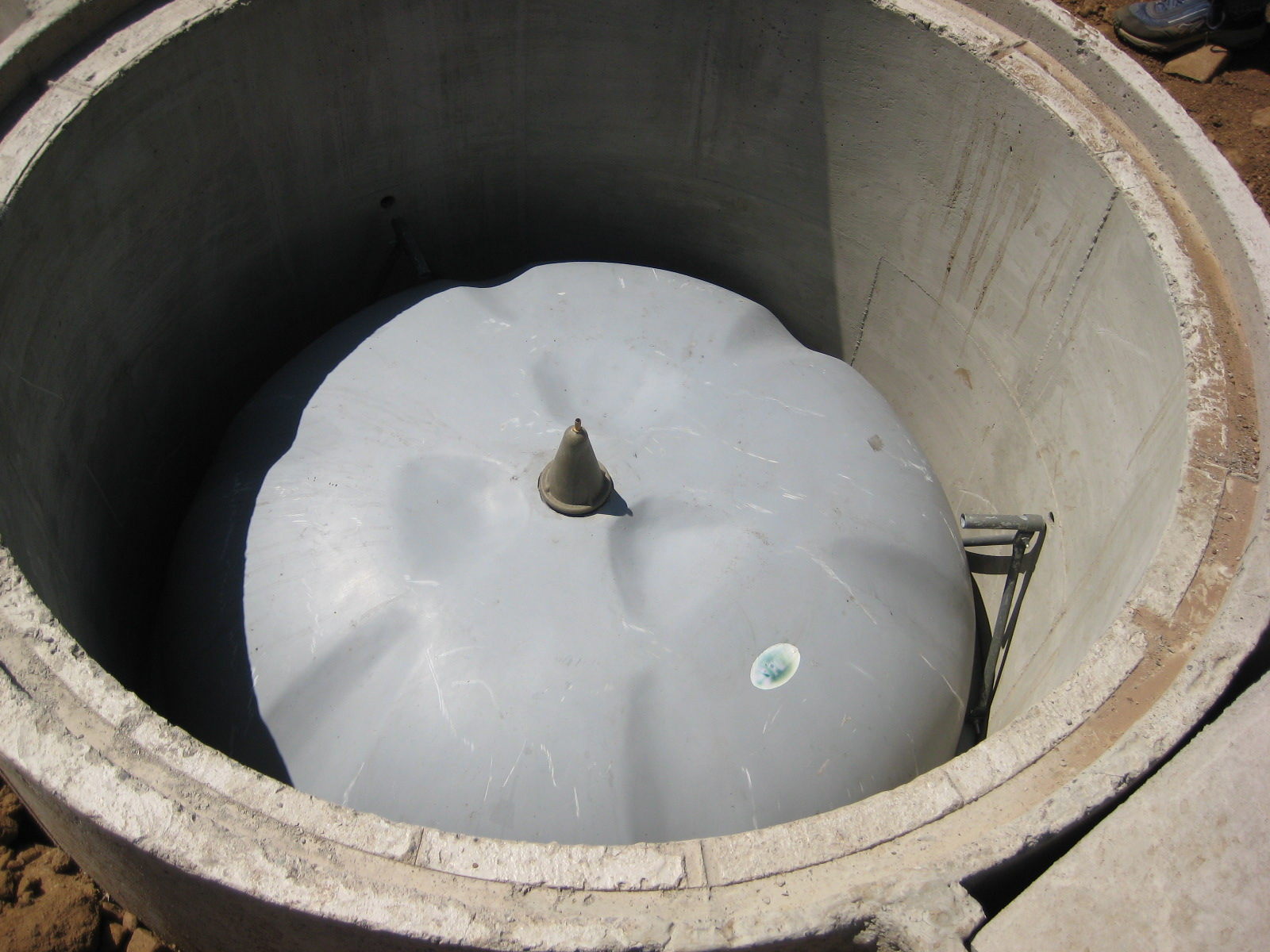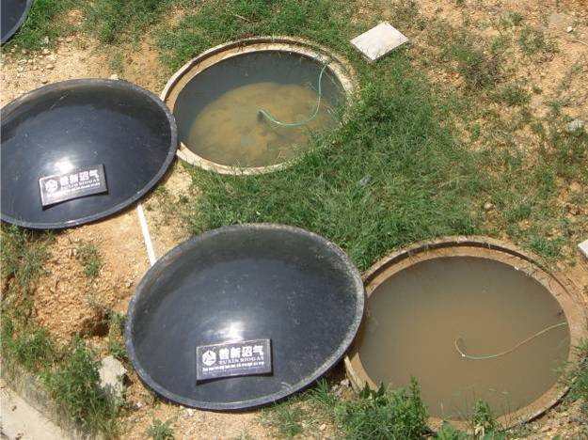

The working principle of storage tank is performed by the pressure, produced by water inside of tank.
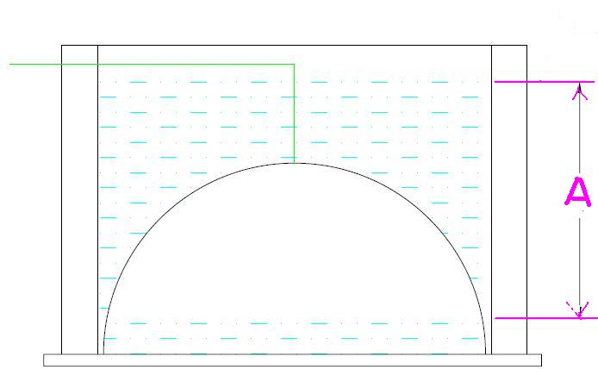

The pressure is caused by the distance between water level of gasholder and water level of concrete tank

The pressure change when storage biogas or using biogas:

1. Change of water level when storaging biogas:
The water level of concrete storage tank is increasing; the water level of gasholder is decreasing at the same time.
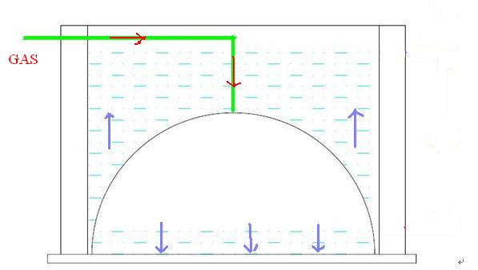

2. Change of water level when using biogas:
The water level of storage tank is decreasing; the water level of gasholder is increasing at the same time
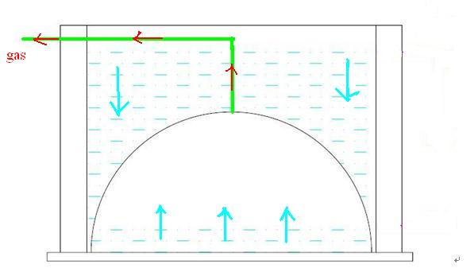

The most important point when using the storage system at the first time, is to
push the air in the gasholder out, before storage biogas, in order to avoid the biogas inside of gas holder to explode because of mixing with air and not to burn because of low concentration

The way:

Removing the gas pipe which connects the gasholder, and then feeding water in the storage tank until above the gasholder, showing:
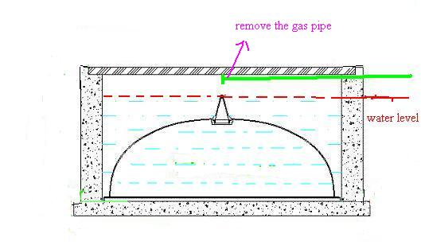

Raw material needed to produce 1 cubic meters biogas
raw material | Water content (%) | Dray material gas production rate (m3/kg) | raw material needed to produce 1 cubic meters biogas（kg）
raw material | A | B | Dry material | Fresh material
Pig Manure | 82 | 0.25 | 4.00 | 22.23
cow Manure | 83 | 0.19 | 5.26 | 30.96
Chicken Manure | 70 | 0.25 | 4.00 | 13.34
Human Manure | 80 | 0.30 | 3.33 | 16.67
Rice Straw | 15 | 0.26 | 3.84 | 4.53
Wheat Straw | 15 | 0.27 | 3.70 | 4.36
Corn stalks | 18 | 0.29 | 3.45 | 4.21
Fresh grass | 76 | 0.455 | 2.20 | 9.17
Water Hyacinth | 93 | 0.31 | 3.23 | 46.15

The following data are basis on theoretical value and natural temperature
Take 100 kg pig manure for example, according to the above table
Calculating:
Waste * ( 1- A ) * B → 100 * (1-82%) * 0.25 = 4.5 m3 biogas
So 100 kg pig manure can be produce about 4.5 m3 biogas
Data:
① 10 m3 puxin biogas systems can generate 5 m3 biogas if the waste is enough,
② 23 kg pig manure can produce 1 m3 biogas-——→ 23 * 5 = 115 kg pig manure
30 kg cow manure can produce 1 m3 biogas——→30 * 5 =150 kg cow manure
So the suitable quantity of dung which 10 m3 biogas plant needs is 115 kg pig manure or 150 kg cow manure.

You also need to send a person who can speak English to our company in Shenzhen China for about a one week technical training after you have ordered from us if you are available.

The training includes the following parts:
a. To learn and practice how to assemble and dissemble the steel mould.
b. To learn how to build the concrete digester with the steel mould.
c. To learn how to install the gasholder, the pipe system, and the appliances.
d. To learn how to start and how to maintain the biogas system.

The training course will spent three to five days in the company to teach part 1, 3, 4, and stay in a place where some Puxin biogas plants are in construction to watch the whole processes of construction of a real puxin biogas plant or one or two PUXIN biogas plant had been built.

4. Introduction of Puxin family size biogas plant

Puxin family size biogas system is composed of a 6 or 10 m3 Puxin family size biogas plant, pipe routes, and gas purify devices and gas appliances or small power biogas generator. Puxin family size biogas system is mainly applied to farmhouse or domestic house to treat livestock waste, straw, human sewage and food waste.

(1) The structure：
Puxin family size biogas plant is composed of a concrete digester and a glass fibre reinforced plastic gas-holder. The digester is 6 or 10 m3 of capacity. The gas-holder is 1.6 m of diameter, 0.6 m of height and 1 m3 of capacity.
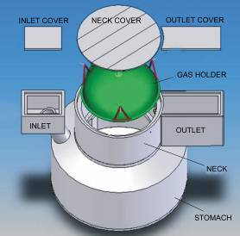

（2）The features ：
- Easy and quick to be built
- Highly industrialized
- Solid organic material (straw and grass etc.) can be used
- Easy to maintain
- Durable
- Excellent safety feature
- Low cost
1）Easy and quick to be built：
- Any working mason through one day’s study is able to build Puxin family size biogas plant with 100% success rate.
- A Puxin family size biogas plant can be built within 48 hours.

Contrast of the technical requirements for the builders
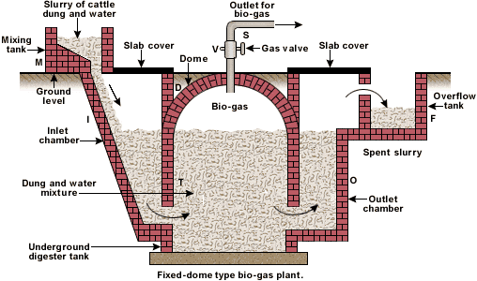

Items | Traditional fixed dome biogas plant | Puxin biogas plant
Airtight craft | Highly required | Not required
Ability to understand blueprints | Highly required（build by hand depending the blueprints） | Not required (cast by mould)
Ability to build the arch | Highly required (build by hand) | Not required (cast by mould)
To judge and deal with gas leaking | Highly required | Lowly required
To judge and deal with water leaking | Highly required | Required
Training period | About 3 month | About one week
Period to become a proficient builder | 1－2 years | About one month
Requirement of the people to be trained | Medium educated, strong ability to master skills | Not Educated, medium ability to master skills
Success rate | Not 100％ guaranteed | 100％ guaranteed

Contrast of the technical requirements for the builders
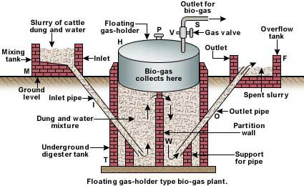

Items | The floating gasholder biogas plant | Puxin biogas plant
Cost | High, The gasholder made with steel is about 1000kg in weight, so the cost of manufacture, transportation and installation is very high. | Low, the gasholder made with fibre glass plastic is only 30kg in weight, so the cost of manufacture, transportation and installation is much lower.
Installation | Difficult, because the gasholder is very heavy (1000kg) the installation of it is difficult. | Easy, because the gasholder is very light (only 30kg) the installation of it is easy.
Lifespan | Short, the steel gasholder is put in the open air, so it can be rusted by air, rain and sunshine. The lifespan is less than 5 years. | Long, the fibre glass plastic gasholder is always in water, so can’t be rusted by air, rain and sunshine. The lifespan is more than 10 years.
The gas pressure | Low, the gas pressure is lower than 2kpa, so the generator that requires a min 4kpa gas pressure can’t work | High, the gas pressure can reach 10kpa that is high enough to run the generator.

2）Highly industrialized：
- Fit for cosmically and fleetly spread: The steel mould and the gas-holder can be mass-produced in factory. So, the biogas plant can be cosmically and fleetly built.
- Quality of the biogas plant is highly guaranteed. Every digester duplicated by the steel mould can fit every gas holder duplicated by mold.
3）Solid organic material (straw and grass etc.) can be used
 | Traditional fixed dome biogas plant | Puxin biogas plant
Fluidities (like animal wastes) | Allowed | Allowed
Solids (like straw and grass) | Not allowed  (because of the difficulty to replace solid fermentation material ) | Allowed  (convenient to replace solid fermentation material)
4）Easy to maintain
Items | The traditional fixed dome hydraulic biogas plant | The Puxin Biogas plant
To mend the gas leak of gas-holder | Dangerous and difficult  The job is done inside the biogas digester; there is a possibility of poisoning.  The leak can not be found. | Safe and easy  The job is done on ground; there is no possibility of poisoning. The leak can be seen, and can be mended directly.
To mend the water leak of the digester | Dangerous  The digester’s outlet is too small that the air circulation in the digester is bad. So, there is a possibility of poisoning. | Safe  The digester’s outlet is large enough that the air circulation in the digester is good. So, there is no possibility of poisoning.

5）Durable：
The concrete digester can last over thirty years. The glass fibre reinforced plastic gas-holder can last over ten years. When the gas-holder is worn-out, a new one can replace. So the Puxin biogas plant can last over thirty years.

6）Excellent safety feature：
There is no possibility of biogas poisoning to the users. When the gas-holder is taken out from the digester, there is no biogas left in the digester. The digester’s outlet is 1.5m in diameter that is large enough to keep sufficient fresh air in the digester. So, it is safe to repair the digester, and safe to replace fermentation material.

7）Low cost
The cost to build Puxin biogas plant is lower than cost to build traditional Chinese fixed dome biogas plant and much lower than the cost to build Indian floating gasholder biogas plant.

5. Products used to build Puxin family size biogas system

- STEEL MOULD WITH OUTER 10M3
(proprietary)
The 10m3 steel moulds are used to construct 6 and 10m3 concrete digesters. The digester can be built within 48 hours. The steel mould is reusable. The product made by steel, it is composed of 93 steel moulding boards and 19 work pieces. It is applied to construct the concrete digester of the Puxin biogas plant, the Biogas plant Volume is 10M3, Inner Φ280cm, Outer Φ300cm, Depth 120cm, Neck inner Φ166cm, Outer Φ196cm, Depth 110cm, the work pieces including Insertion type concrete vibrator, Tools and Mould Hooks. The product won a number of national patents.
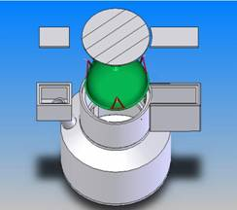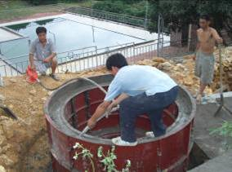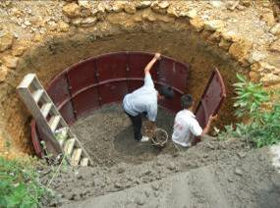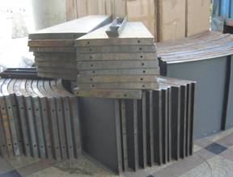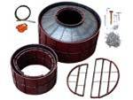

- GASHOLDER 1.0 M3
(proprietary)
This product is one of the main components of the Puxin Biogas Plant, and is composed of a container made with glass fibre reinforced plastic and three steel supports. On the top of the gas –holder there is a valve that can eliminate the atmospheric pressure.Φ164cm, High 60cm. The product won a number of national patents.
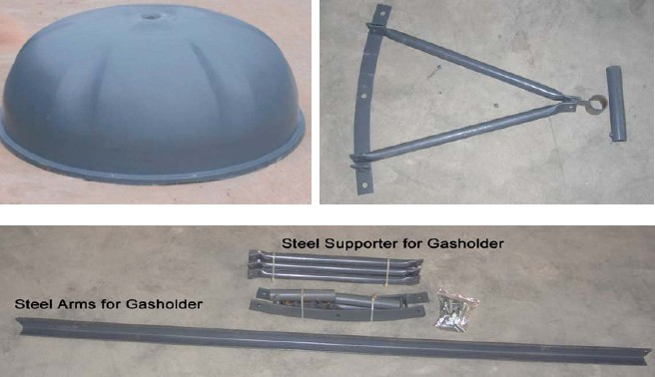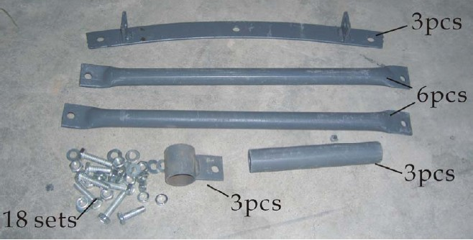
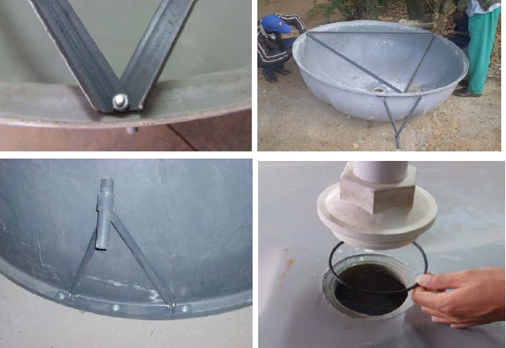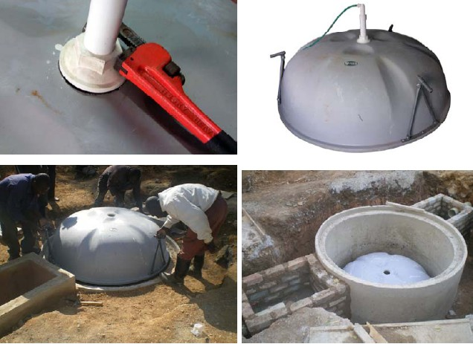

3) BIOGAS FITTING
This product is composed of 30m(3.5kgs) Φ9mm PVC soft pipe, 1pc pressure gauge 16KPa, 1pc desulpharize 1KG ,5pcs valve, 20pcs Iron buckle, 30pcs Plastic clip and 7pcs Plastic joining. The PVC soft pipe is use to transport biogas from Puxin biogas plant to biogas appliances (stove, water heater, rice cooker, lamp etc). The desulpharize is use to removal of H2S in the biogas.
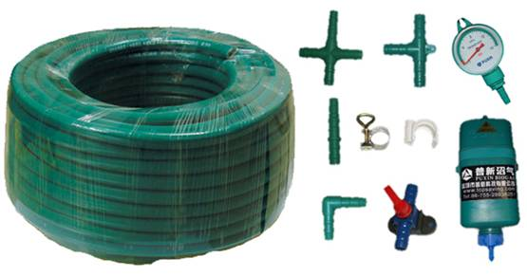

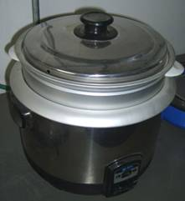
4) BIOGAS RICE COOKER 2L
Largest rice quantity: 1.6kg
Gas category: biogas
EX-compressive force of cooking stove:
1600Pa
Gas consumption: 129g/h
Rating caloric: 1.0kw

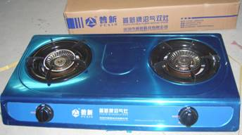
5) BIOGAS STOVE DOUBLE BURNER
Suitable gas: Biogas
Heat load: 2.8KW
Gas consumption rate: 0.45m3/h (for one burner)
Heat efficiency : >57%
Gas entrance pressure: 1600Pa
Fire maker efficiency : >98%

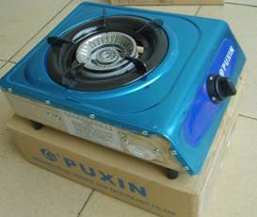
- BIOGAS STOVE (SINGLE BURNER)
Main technical parameters:
Suitable gas: Biogas
Heat load: 2.8KW
Gas consumption rate: 0.45m3/h
Heat efficiency : >57%
Gas entrance pressure: 1600Pa
Fire maker efficiency : >98%

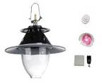
7) BIOGAS LAMP WITH FIRE MAKER
Gas consumption: 0.07m3/h
310×300×260mm /8 sets, 0.5kg/set
HS CODE: 94055000

Financial Proposal (FP)

Date: 29 December 2011

The cost of building Puxin family size 6m3 and 10m3 and 100m3 biogas system is composed of three sections

The first section: The best quality

The second section: The biogas products are not expensive
Local cost
1. The construction material and the manpower cost
Cost breakdown of a PUXIN 6m3 biogas plant
Item | (The earth work is not included) Material (manpower) | quantity
1 | Glass fiber reinforced plastic Gasholder | 1
2 | Smashed stone | 2.4 m3
3 | Sand | 2.0 m3
4 | cement | 850 kg
5 | Brick（60×120×240mm） | 100
6 | Plastic pipe （Φ150×1800mm) | 2
7 | concrete bar (Φ6) | 8kg
8 | manpower | 6 man day in total:  4 man×1 day (install the mould and cast)+2 man×1 day (disassemble the mould, build inlet, outlet and install pipe and appliances)
9 | Biogas appliances
10 | For depreciation of the steel mould

Cost breakdown of a PUXIN 10m3 biogas plant
Item | Material (manpower) | Quantity
1 | Glass fiber reinforced plastic Gasholder | 2
2 | Smashed stone | 4m3
3 | Sand | 3.5m3
4 | Cement | 1400kg
5 | Brick（60×120×240mm） | 100
6 | Plastic pipe （Φ150×1800mm) | 2
7 | Concrete bar (Φ6) | 8kg
8 | Manpower | 6 man×1 day (diging hole)+  6 man×1 day (casting)+  2 man×1 day (to build inlet, outlet and install pipe system)
9 | Biogas appliances
10 | For depreciation of the steel mould

2. Other cost locally
6. Introduction of Puxin medium size biogas plant
1. A 100M3 biogas system built in a school in Shenzhen China to treat human waste and food waste, biogas is provided as fuel for cooking. The water is provided for greening. It is composed of 1 set of 100m3 biogas plants, 10 sets biogas storage tanks and 4 sets biogas storage bag.

2. A 100M3 biogas system built in Huizhou China to treat pig manure, the biogas is provided as fuel for cooking and bathe. It is composed of 1 set of 100m3 biogas plant and 9 sets biogas storage tanks
- A 210M3 biogas system built in Guangdong China to treat pig manure; the biogas is provided as fuel for cooking and generates electricity. It is composed of 21 sets of 10m3 biogas plant
5. An 80M3 biogas system built in Shenzhen China to treat organic garbage (horse manure, food waste and grass); biogas is provided as fuel for cooking and bathe. It is composed of 8 sets of 10m3 biogas plant.

Local cost
- The construction material and the manpower cost

1. The construction material and the manpower cost

Cost breakdown of a PUXIN 100m3 biogas plant

Cost Breakdown of 1 set of 100 M3 Puxin Biogas Plant
SN | Item | Quantity | Unit Cost | Amount | Note
I | Materials
1 | Glass fiber reinforced plastic Gasholder 1.2m3 | 1
2 | GLASS FIBRE PLASTIC COVER | 1
3 | Concrete | 30 M3
4 | Concrete bar | 3500 Kgs
5 | Brick（60×120×240mm） | Pcs |  |  | Inlet and outlet
6 | PVC pipe（Φ200mm） | 1Sets |  |  | Inlet and outlet
7 | DESULFURIZER & DEHYDRATION | 1
8 | Gas pipe, valves and fitting | 1Sets
9 | Water pump | 1
10 | Sewage Pump | 1
TOTAL
II | Appliances /Accessories ()
11 | Biogas pump 1.5KW(30~50M3/h) | 1
12 | Dewatering Equipment
13 | GAS STORAGE BAG 50M3 | 1
14 | BIOGAS GENERATOR 8KW | 1
TOTAL
Ⅲ | Manpower
15 | Skilled Labor (casting,  to build inlet, outlet and install pipe system) | 1 man×3 day
16 | Unskilled Labor | 25 day/man
17 | Excavation of soil （By machine ） | Earthwork 350 M3
Ⅳ | For depreciation of the steel mould | 1
Ⅴ | After sales services

The third section
Cost for the trainees come to our company in Shenzhen City in China for three to one week technique training.
7. Introduction of Puxin minimum size biogas plant
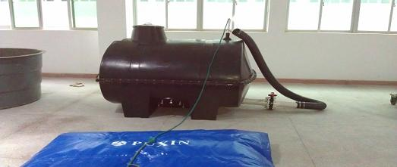
Portable Solar Digester
The product is composed of an anaerobic fermentation tank, a gas storage bag, a gas pump, a solar charger, as well as gas pipeline and appliances. The anaerobic fermentation tank consists of mainly an upper tank and a lower tank. The product has the following advantages:
1. Easy and quick to install. It can be installed by the Users themselves within two hours;
2. Convenient to transport, because its total weight is only 120 kg.
3. Wide rang of fermentation material: It is suitable to use food waste, grass, leaves and straw as fermentation material.

High gas production rate: the gas production rate can reach 1.5m3
The cost this whole system: one set is about $1500. It is very suitable for a family about three or four people.

The cost of flight
The cost here for hotel and meal
The total cost for a person of one week training is USD 560
Hotel: USD 350 (about USD 50/room.day.person)
Food USD 210 (about USD 30/day)
Training itself and transportation for visit of the biogas plants nearby is free for any of our customers who come to our company

Collusion: Our biogas plant has been exported for more than sixty countries. Our company provides the best quality and service for our customers. I hope our biogas plant will help reduce the crisis of energy in the world.
Yours Sincerely
Jack liu
Shenzhen Puxin Technology Co. Ltd
2nd floor, Bldg 4, Masha Xuda High Tech. Industry Park,
49 Jiaoyu North Rd, Gaoqiao District, Pingdi Street,
Longgang, Shenzhen, P. R. China,
Postal code: 518117
Tel: 86—755—89323983 Fax: 86—755—89323983
Mobile:86—15013555690
Website: www.puxinbiogas.com
Alibaba: http://puxinbiogas.en.alibaba.com
E-mail:info6@puxintech.com
Skype: jack.liu.55
Msn: Jackliu55@msn.cn

